Challapata Market Update, 7.6.2014

Price Analysis
On 7 June, white quinoa traded in Challapata reached $5.62. Prices of red quinoa have increased to $5.14 and black quinoa has dropped to $3.21.
Since 24 May, when quinoa costed $5.14 prices have been increasing weekly to $5.30 on 31 May and reach $5.62 last weekend on 7 June. The price for white quinoa is more fluctuating than the prices for red and black varieties. In May, red and black quinoa was stable at $4.83 (red) and $4.02 (black). Only since last weekend, red quinoa has increased from $4.82 to $5.14. Oppositely, the black quinoa price moves downwards from $4.02 to $3.21.

Price Overview
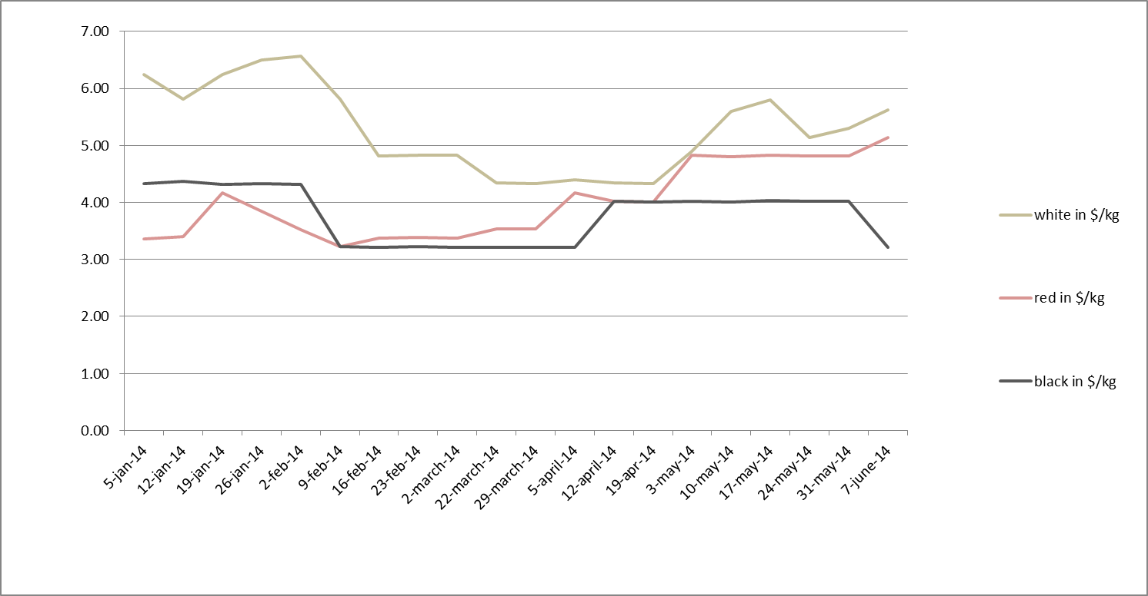
Price Record

date | colour | in Bolivianos/qq | in $/kg
 | white | 1,950 | 6.24
5-jan-14 | red | 1,050 | 3.36
 | black | 1,350 | 4.32
 | white | 1,800 | 5.82
12-jan-14 | red | 1,050 | 3.39
 | black | 1,350 | 4.36
 | white | 1,950 | 6.24
19-jan-14 | red | 1,300 | 4.16
 | black | 1,350 | 4.32
 | white | 2,030 | 6.50
26-jan-14 | red | 1,200 | 3.84
 | black | 1,350 | 4.33
 | white | 2,050 | 6.56
2-feb-14 | red | 1,100 | 3.52
 | black | 1,350 | 4.32
 | white | 1,800 | 5.81
9-feb-14 | red | 1,000 | 3.23
 | black | 1,000 | 3.23
 | white | 1,500 | 4.82
16-feb-14 | red | 1,050 | 3.37
 | black | 1,000 | 3.21
 | white | 1,500 | 4.83
23-feb-14 | red | 1,050 | 3.38
 | black | 1,000 | 3.22
 | white | 1,500 | 4.82
2-march-14 | red | 1,050 | 3.38
 | black | 1,000 | 3.22
 | white | 1,350 | 4.34
22-march-14 | red | 1,100 | 3.54
 | black | 1,000 | 3.21
 | white | 1,350 | 4.33
29-march-14 | red | 1,100 | 3.53
 | black | 1,000 | 3.21
 | white | 1,370 | 4.40
5-apr-14 | red | 1,300 | 4.17
 | black | 1,000 | 3.21
 | white | 1,350 | 4.34
12-apr-14 | red | 1,250 | 4.02
 | black | 1,250 | 4.02
 | white | 1,350 | 4.33
19-apr-14 | red | 1,250 | 4.01
 | black | 1,250 | 4.01
 | white | 1,520 | 4.89
3-may-2014 | red | 1,500 | 4.83
 | black | 1,250 | 4.02
 | white | 1,750 | 5.60
10-may-2014 | red | 1,500 | 4.80
 | black | 1,250 | 4.00
 | white | 1,800 | 5.80
17-may-2014 | red | 1,500 | 4.83
 | black | 1,250 | 4.03
 | white | 1,600 | 5.14
24-may-2014 | red | 1,500 | 4.82
 | black | 1,250 | 4.02
 | white | 1,650 | 5.30
31-may-2014 | red | 1,500 | 4.82
 | black | 1,250 | 4.02
 | white | 1,750 | 5.62
7-june-2014 | red | 1,600 | 5.14
 | black | 1,000 | 3.21

The Meaning of the Challapata Price
The price figures below give an insight into the market price for Bolivian quinoa as it is determined weekly on the Challapata market in the Bolivian Southern Altiplano. Challapata is the main national open market for quinoa, named “Quinoa Wallstreet” for the consequences its price setting dynamics have on international trade. Every week, producers and traders from all over the country come to the small town to buy and sell quinoa. The price for which the grain is traded is decided weekly and can raise or drop within the day. The Challapata price is determined by supply and demand. It is so important since it is the benchmark for most exporting companies and associations. The price politics of most companies take the Challapata price as a basis and then adds 50, 60 or 100 Bolivianos extra.
At Mercadero, we update the Challapata price every fortnight and explain why the price moves in a certain direction. The price refers to white quinoa, which can be both organic and non-organic but should mainly be sold as non-organic due to the spot market character of the Challapata market (hence, back-tracing is not easily done).

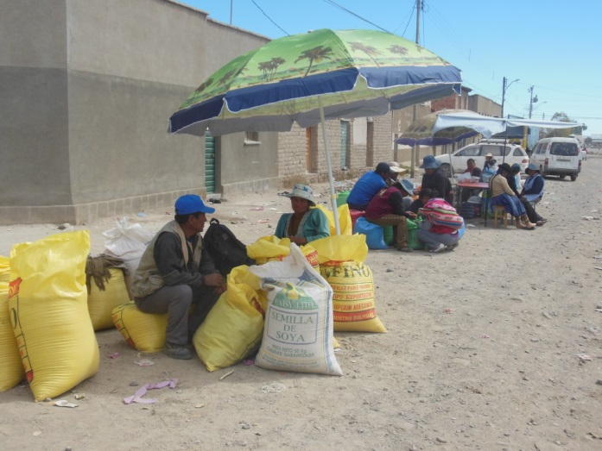
Quinoa farmers and their produce in Challapata, Picture: Annika Gabriel, March 2013.

